Probas de rendemento
https://santiagodecompostela.gal/
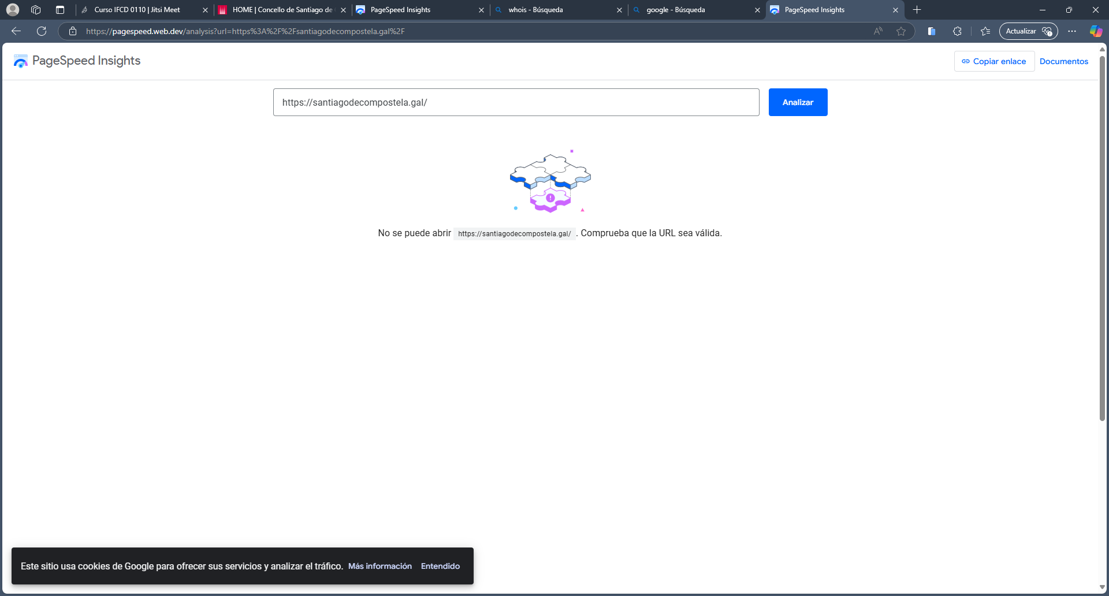

Compatibilidade navegadores
Non se observan diferencias nos navegadores sinalados Chrome, Firefox ou Edge

Validación de Código HTML/CSS:
I got the following unexpected response when trying to retrieve <https://santiagodecompostela.gal/gl>:
500 Can't connect to santiagodecompostela.gal:443 (Connection timed out)
If you made recent changes to your domain name (DNS) configuration, you may also want to check that your domain records are correct, or ask your hosting company to do so.

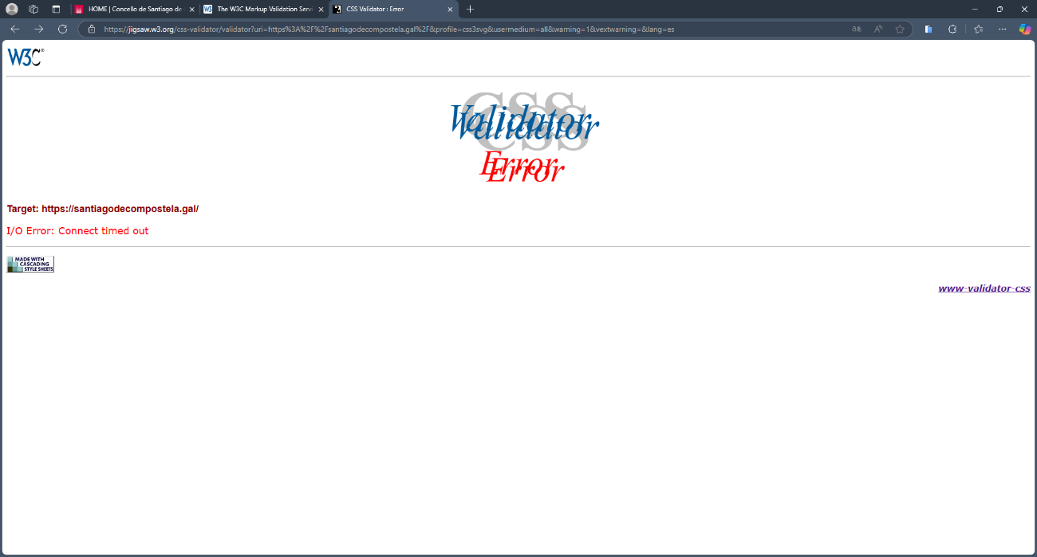

Axe Dev Tools
Anexo Santiago
